TutorTube: Polar and Nonpolar Compounds Spring 2021
Introduction
Hello and welcome to TutorTube, where The Learning Center’s Lead Tutors help you understand challenging course concepts with easy to understand videos. My name is Rebecca, Lead Tutor for Biology and Chemistry. In today’s video, we will explore Polar and Non-Polar Compounds. Let’s get started!

Definitions
First, let's define polar and nonpolar molecules:
A polar molecule occurs when there is an unequal sharing of electrons within a bond.
A nonpolar molecule occurs when there is equal sharing of electrons within a bond

Quick Ways to Distinguish Polar and Non-Polar Molecules
Let's first see some ways to distinguish nonpolar and polar molecules.
Whenever you see a monoatomic atom such as helium, neon, argon, and so on, it is nonpolar.
Whenever you see diatomic molecule of two identical atoms, such as nitrogen molecule (N₂), chlorine molecule (Cl₂), hydrogen molecule(H₂), and so on, there is equal sharing of electrons between the atoms involved, therefore, they are a nonpolar.
Another way to distinguish nonpolar molecules from polar molecules is to see if the compound is only composed of carbon and hydrogen atoms. So, whenever you see hydrocarbons, such as methane, ethane, benzene, and so on, it is a nonpolar molecule.
But when you’re dealing with compounds that are not diatomic, monoatomic, or even hydrocarbons, check to see if the compound is has a symmetric distribution of charges. Such a compound typically has a central atom that bonds all of its valence electrons equally to identical terminal atoms. Let’s take carbon dioxide as an example. Since the central atom, carbon, bonds all 4 of its valence electrons equally to two terminal atoms, oxygen, it has a symmetric charge distribution, and is therefore nonpolar.
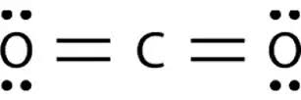
Figure 1: Carbon dioxide Lewis Structure
Another example is carbon tetrafluoride in which carbon as the central atom uses all of its valence electrons to share equal bonds with 4 fluorine atoms. This compound has a symmetrical distribution of charges, and so it’s nonpolar.
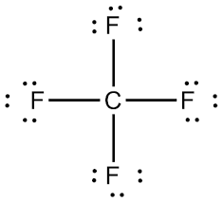
Figure 2: Carbon tetrafluoride Lewis Structure
One last example is boron trifluoride. The central atom boron uses all 3 of its valence electrons to share equal bonds with 3 fluorine atoms. So, this compound is also non-polar.
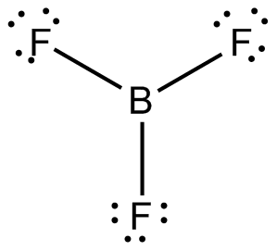
Figure 3: Boron trifluoride Lewis Structure
Calculating the electronegativity difference between the bonded molecules can also help us determine whether a compound is nonpolar or polar. If the electronegativity difference is less than 0.4, then the substance is nonpolar. For example, in the compound iodine monobromide, Iodine has an electronegativity value of 2.66 while bromine has an electronegativity value of 2.96. The electronegativity difference between these two atoms is 0.3 which is less than 0.4, therefore, iodine monobromide is a nonpolar molecule.
We can also identify nonpolar molecules by checking to see if there is zero net dipole moment in the compound. Take trans-1,2-dibromoethene for example. In this compound, two carbons are bonded to bromine and hydrogen atoms in trans-configuration.
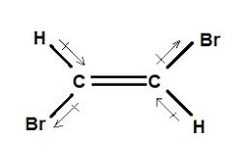
1 2
Figure 4: trans-1,2-dibromoethene Structural Formula
Bromine is a more electronegative element compared to carbon, therefore the bond electrons shared between them are more attracted to bromine making the dipole moment in the direction towards bromine. While the bromine bonded to first carbon is attracting the bonded electrons towards itself, the bromine on second carbon is doing the same making the dipole moment is in the opposite direction. Therefore, dipole moment in these two bonds cancel each other out. In the bond between carbon and hydrogen, since carbon is more electronegative than hydrogen, it is going to attract the bonded electrons towards itself. Since the carbon-hydrogen bonds are in trans-configuration, the dipole moment in the bonds will cancel each other out. Therefore, overall, there is going to be zero net dipole moment making the entire compound nonpolar.
Now let's see how to distinguish polar molecules from nonpolar molecules. First and foremost, if a compound has hydrogen bonding within it, it is a polar molecule. This means that if there is a hydrogen atom directly bonded to fluorine, nitrogen, or oxygen, then it is a polar molecule. Even when it comes to methanol (CH₃OH) where the methyl (CH₃-) part does not have H-bonding, the entire compound is still considered polar because the hydroxyl group (-OH) involves H-bonding.
If the compound you're looking at has an asymmetric charge distribution, then it is a polar molecule. The compound methyl chloride, CH₃Cl, has three hydrogen atoms and one chlorine atom bonded to the central carbon. Since carbon is not bonded to identical terminal atoms, there is an asymmetric charge distribution in which most of the electrons will concentrate around chlorine as it is the most electronegative element in the compound. This makes it a polar compound.
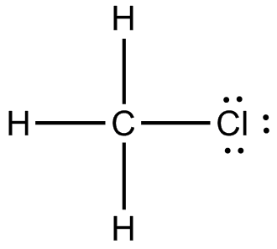
Figure 5: Chloromethane Lewis Structure
Similarly, Trichlorofluorosilane (SiFCl₃) has an asymmetric charge distribution because one fluorine atom and three chlorine atoms are bonded to the central atom silicon. There will not be equal sharing of electrons because the terminal atoms are not identical. Thus, this compound is polar.
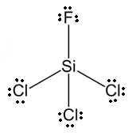
Figure 6: Trichlorofluorosilane Lewis Structure
Let’s take a look at sulfur dioxide (SO₂). You need to draw out the Lewis structure to see if its charge distribution is symmetrical or not. Sulfur forms a double bond with each oxygen and will be left with a lone pair. This molecule will have a bent molecular shape because of the lone pair on the central atom sulfur. The charge distribution is not symmetrical, making it a polar molecule.
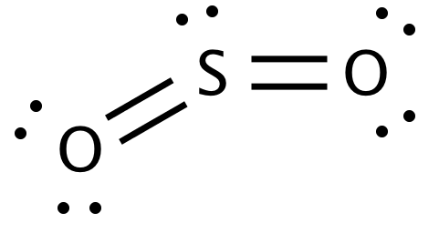
Figure 7: Sulfur dioxide Lewis Structure
If you see two atoms with great electronegativity difference bonded together, it is most likely a polar molecule. Whenever the electronegativity difference between two covalently bonded atoms is greater than 0.4, it is a polar molecule. Let’s look at sulfur dioxide (SO₂) as an example, Sulfur’s electronegativity is 2.58 and oxygen’s electronegativity is 3.44. The electronegative difference between S and O is 0.86, so this molecule is surely polar. Go ahead and find the electronegativity difference between selenium and chlorine. If the value you find is greater than 0.4 but less than 1.8, then it should be a polar molecule. If the electronegativity difference happens to be greater than 1.8, then the compound you're looking at is most likely formed from an ionic bond. But if the difference is less than 0.4, then it is probably a non-polar molecule.
A final way I’m going to show you how to identify a polar molecule is by determining the net dipole moment of a compound. If it is not zero, then it is a polar molecule. Let's look at cis-dibromoethene as an example.
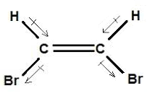
Figure 8: cis-dibromoethene Structural Formula
In the bond between carbon and bromine, since bromine is the more electronegative element, the dipole moment of the bond is in the direction towards bromine. Both carbon-bromine bonds are on the same side of the compound, and therefore the dipole moments in the bonds are not in opposite direction, and so they won’t cancel each other out. Similarly, since the carbon-hydrogen bonds are on the same side of the compound, then the dipole moments are not in opposite directions, so they cannot cancel each other out. Therefore, this compound has a non-zero dipole moment, thus, it is polar.

Outro
Thank you for watching TutorTube! I hope you enjoyed this video. Please subscribe to our channel for more exciting videos. Check out the links in the description below for more information about The Learning Center and follow us on social media. See you next time!

References
Figure 1: Shapley, Patricia. “Carbon Dioxide”. University of Illinois. 2012. http://butane.chem.uiuc.edu/pshapley/genchem2/B3/1.html
Figure 2: “Carbon Tetrafluoride”. Chemical Education Digital Library. http://www.chemeddl.org/resources/models360/models.php?pubchem=6393
Figure 3: “Boron Trifluoride”. Chemical Education Digital Library. http://www.chemeddl.org/resources/models360/models.php?pubchem=6356
Figure 4: “There are three different possible structures (known as isomers) for a dibromoethene molecule”. Study.com. https://study.com/academy/answer/there-are-3-different-possible-structures-known-as-isomers-for-a-dibromoethene-molecule-c-2h-2br-2-one-of-them-has-no-net-dipole-moment-but-the-other-two-do-draw-a-structure-for-each-isomer-inc.html
Figure 5: “Chloromethane”. Chemical Education Digital Library. http://www.chemeddl.org/resources/models360/models.php?pubchem=6327
Figure 6: National Center for Biotechnology Information. "PubChem Compound Summary for CID 139862, Trichlorofluorosilane" PubChem, https://pubchem.ncbi.nlm.nih.gov/compound/Trichlorofluorosilane.
Figure 7: “Sulfur dioxide”. Chemical Education Digital Library. http://www.chemeddl.org/resources/models360/models.php?pubchem=1119
Figure 8: “There are three different possible structures (known as isomers) for a dibromoethene molecule”. Study.com. https://study.com/academy/answer/there-are-3-different-possible-structures-known-as-isomers-for-a-dibromoethene-molecule-c-2h-2br-2-one-of-them-has-no-net-dipole-moment-but-the-other-two-do-draw-a-structure-for-each-isomer-inc.html

